Sticks & Stones Storyboard

**Theme:** Adventure / Survival Horror

**Hero / Player:** Haidyn Terranus

**Villian:** The Shadow & Its Messenger: Einstute, The Blind Abomination.

**Name:** Dammendrond – The Forest of Sins

Rooms (16)

1. Logging Camp
   1. Section 1
   2. Section 2 - **Item:** *Sigil – Depression*
2. Worker’s Tent City –
   1. Section 1 - **Item:** *Sigil – Regret*
   2. Section 2
3. Den of The Blind – **Item:** *Sigil - Fury*
4. Underground Entrance
5. Forsaken Camp – **Item:** *Sigil - Salvation*
6. Trading Post – **Item:** *Sigil - Greed*
7. Tree House
8. Makeshift Slave Quarters
   1. Section 1
   2. Section 2 - **Item:** *Sigil - Fear*
9. Corroded Wagon – Player Start Location
10. Jagged Cliffs – **Item:** *Vision*
11. Splinter Gardens
    1. Section 1 - **Item:** *Sigil – Strength*
    2. Section 2
12. Gravestone Father’s Fortress – End Location – Villian Area

Items (7)

Sigils – Recorded in a tome the player carries

1. Fury
2. Regret
3. Depression
4. Fear
5. Salvation
6. Greed

A “Vision”:

* Tells the player the order of the Symbols. If they put them in wrong, they die. The Vision will change the order of the Symbols every game.

**< - + -The Story of Sticks & Stones - + - >**

Long ago, paths through Dammendrond’s forest were simple. . .

. . . messengers, traders, and travelers alike would be seen along its winding, resourceful routes at all hours of the day. Though easy enough to navigate, the forest… seemingly alive… guided settlers to encampments that none had ever witnessed being built. Though… after The Shadow’s occupation, its champion holds a death grip over Dammendrond’s lands; its voracious hunger birthed from the tormented timber’s self-defense.

It hears the faint sounds of life… and it answers in kind…

…vomited from the earth below, the Gleefully Gluttonous itself comes to smother the forest’s final call… Einstutic, The Blind, now stalks Dammendrond, its jagged teeth tearing deep gashes into the terrain as it begins to inject its infection into the bruised lands…

Guarded by the lashing tides of rotting trees and hidden paths. . .

. . . sixteen pylons lie scattered deep within Dammendrond’s defiled carcass of settlements. Unable to reach its hallowed center, Haidyn’s only hope is to find and crack the 6 Pylons containing the six runic symbols within. However, reaching the gates of the Gravestone Father’s Fortress at Dammendrond’s center won’t be so easy… Haidyn must also discover the order in which the pylons were driven…. There, he must order these tainted markings to break the blind abomination’s attachment to our realm. Yet, every second wasted is but one more step the stronger stench of rot glides closer. With every wrong move, the trees seem to twist and turn, murmurs of dark figures abusing the corners of his vision. Time… is running out…

All of the pylons must be destroyed you see…

. . . only then can you open the lacerated gates to access the Gravestone Father’s Fortress remains. Can you strike at the heart of the blind abomination young adventurer… will you shred its decrepit visage from our plane… or fall under its desecrated devotion to hunger…?

Map of Dammendrond

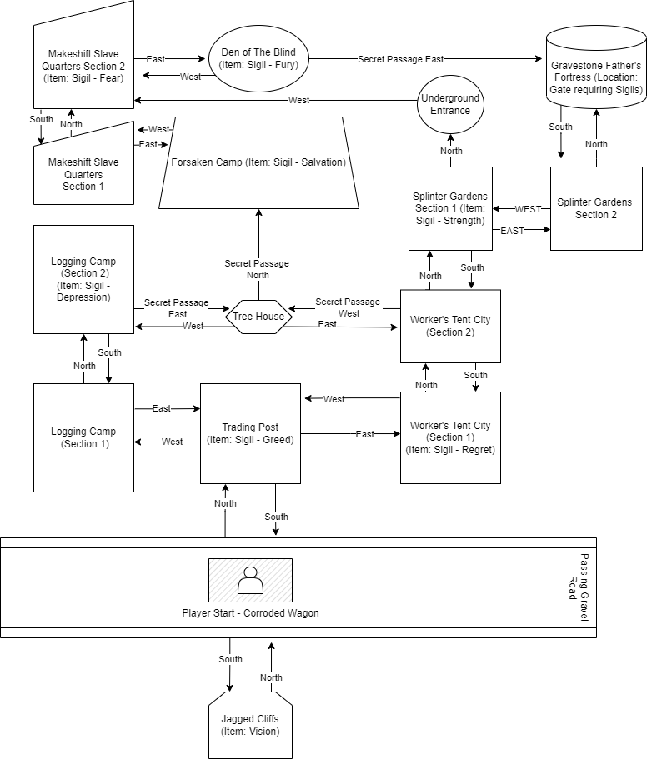

**Note:** Secret Passages will be show notes to assist player in discovery.

**Flowchart for Code to “Move Between Rooms”**

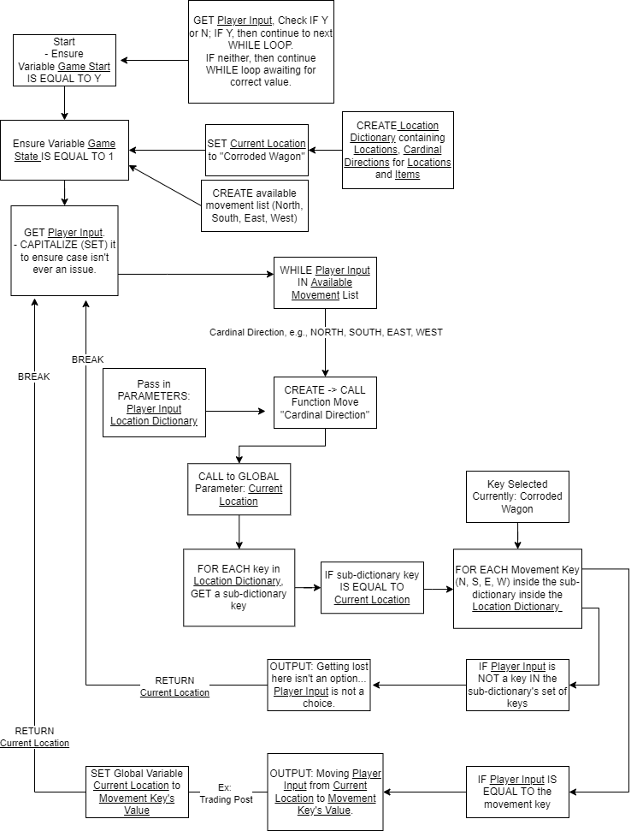

## Flowchart for Code to “Picking Up Items”

